 University of management and Technology
Project Title:
Blockchain-Based Charity Platform with AI Integration

Submitted to:
Sir Shahbaz Qadeer
Submitted by:
Muhammad Talha Shamas f2023266413
Muhammad Rafay Shah f20232661124
Saim Jameel f20232661126

Session
Fall 2023
University of Management and Sciences
C-2 Johar Town Lahore Pakistan

Dedication:
We want to dedicate this to our parents, professors and my institution who always guided me throughout my life.

Final Approval:
⦁ Head of Department ______________________
Department of School of Systems & Technology
UMT Lahore

⦁ Director (Final Year Projects-CS) ______________________
Department of Computer Science. School of Systems & Technology
UMT Lahore
⦁ Supervisor ______________________
School of Systems & Technology UMT Lahore

Acknowledgment:
We are deeply grateful for the unwavering support and guidance of our teachers, whose mentorship kept us motivated and focused throughout this project. Their insights and encouragement played a vital role in shaping our understanding and refining our approach.
Through this journey, we have gained invaluable knowledge and hands-on experience, pushing ourselves to grow as aspiring software engineers and entrepreneurs. This project has not only strengthened our technical skills but also instilled in us a deeper appreciation for teamwork, problem-solving, and innovation.
\This is just the beginning of our learning journey, and we remain committed to exploring, innovating, and improving as we move forward in the field of blockchain technology.

Project Title:
Blockchain-Based Charity Platform with AI Integration

- Starting date 20,october 2024
- Completion date 08,february 2025
- Tools used draw .io
- Documentation

Table of Contents:
Description: 3
Objective: 3
❖ Trust 4
❖ Efficiency 4
❖ Fraud Prevention: 4
❖ Donor Engagement 4
❖ Decentralization 4
➢ Security: 4
Blockchain Security: 4
AI Security: 4
Data Privacy: 4
Smart Contract Security: 4
➢ Stakeholders: 5
➢ Functional Requirements: 5
Donation Management: 5
Smart Contracts: 5
AI Integration: 5
Transparency Dashboard: 6
Reporting and Analytics: 6
➢ Non-Functional Requirements: 6
❖ Scalability 6
❖ Performance 6
❖ Usability 6
❖ Interoperability 6
❖ Reliability 6
❖ Compliance 6
➢ System Requirements: 6
Blockchain Network: 7
AI Framework: 7
Backend 7
Frontend: 7
Cloud Infrastructure: 7
Security Tools: 7
Conclusion: 7
Sequence Diagram 8
Use Case 8
Class Diagram 9

Description:
The Blockchain-Based Charity Platform with AI Integration is a decentralized, transparent, and secure platform designed to revolutionize the charity and donation ecosystem. By leveraging blockchain technology, the platform ensures transparency, traceability, and immutability of transactions, while AI integration enhances decision-making, fraud detection, and donor engagement. The platform aims to connect donors, charities, and beneficiaries in a trustless environment, ensuring that funds are utilized efficiently and ethically.

Objective:
- Transparency: Provide a transparent ledger of all transactions to ensure donors can track how their contributions are used.
- Trust: Build trust among stakeholders by eliminating intermediaries and ensuring funds reach the intended beneficiaries.
- Efficiency: Streamline donation processes using smart contracts and AI-driven automation.
- Fraud Prevention: Use AI and blockchain to detect and prevent fraudulent activities.
- Donor Engagement: Leverage AI to personalize donor experiences and provide insights into the impact of their contributions.
- Decentralization: Create a decentralized platform to reduce reliance on centralized authorities and ensure fairness.

Security:

Blockchain Security:
- Immutable ledger to prevent tampering with transaction records.
- Cryptographic encryption to secure data.
- Consensus mechanisms (e.g., Proof of Stake) to validate transactions

AI Security:
- AI algorithms for fraud detection and anomaly monitoring.
- Secure AI models to prevent adversarial attacks.

Data Privacy:
- Compliance with GDPR and other data protection regulations.
- Anonymization of sensitive data where necessary.

Smart Contract Security:
- Audited smart contracts to prevent vulnerabilities like reentrancy attacks.
- Regular security updates and patches.

Stakeholders:
- Donors: Individuals or organizations contributing funds.
- Charities: Non-profit organizations receiving donations.
- Beneficiaries: Individuals or communities receiving aid.
- Platform Administrators: Entities managing the platform.
- Regulators: Government or regulatory bodies overseeing charitable activities.
- Developers: Engineers maintaining and updating the platform.
- Auditors: Third-party auditors ensuring transparency and compliance.

Functional Requirements:
User Registration and Authentication:
- Secure user onboarding using blockchain-based digital identities.

Donation Management:
- Ability to donate funds or assets via cryptocurrency or fiat.
- Real-time tracking of donations using blockchain.

Smart Contracts:
- Automated fund release based on predefined conditions.

AI Integration:
- Fraud detection using machine learning models.
- Personalized donor recommendations.
- Predictive analytics for charity impact assessment.

Transparency Dashboard:
- Real-time visualization of fund allocation and usage.

Reporting and Analytics:
- Generate reports for donors, charities, and regulators.

Non-Functional Requirements:
- Scalability: Ability to handle a large number of users and transactions.

- Performance: Fast transaction processing and low latency.

- Usability: Intuitive user interface for donors, charities, and administrators.

- Interoperability: Integration with existing payment gateways and blockchain networks.

- Reliability: High availability and fault tolerance.

- Compliance: Adherence to legal and regulatory requirements.

System Requirements:

Blockchain Network:
- Ethereum, Hyperledger, or a custom blockchain.
- Support for smart contracts.

AI Framework:
- TensorFlow, PyTorch, or similar for AI model development.
- Integration with blockchain for real-time data processing.

Backend:
- Node.js, Python, or Go for server-side logic.
- Database: MongoDB or PostgreSQL for storing non-blockchain data.

Frontend:
- React.js or Angular for a responsive user interface.

Cloud Infrastructure:
- AWS, Azure, or Google Cloud for hosting and scalability.

Security Tools:
- Encryption libraries (e.g., OpenSSL).
- Penetration testing tools for vulnerability assessment.

Conclusion:
The Blockchain-Based Charity Platform with AI Integration is a cutting-edge solution to address the challenges of transparency, trust, and efficiency in the charity sector. By combining blockchain and AI technologies, the platform ensures secure, transparent, and impactful charitable activities, fostering a culture of trust and accountability among all stakeholders.

Sequence Diagram
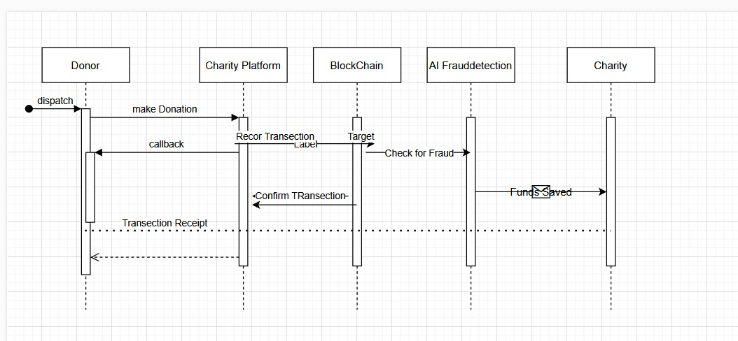

Use Case
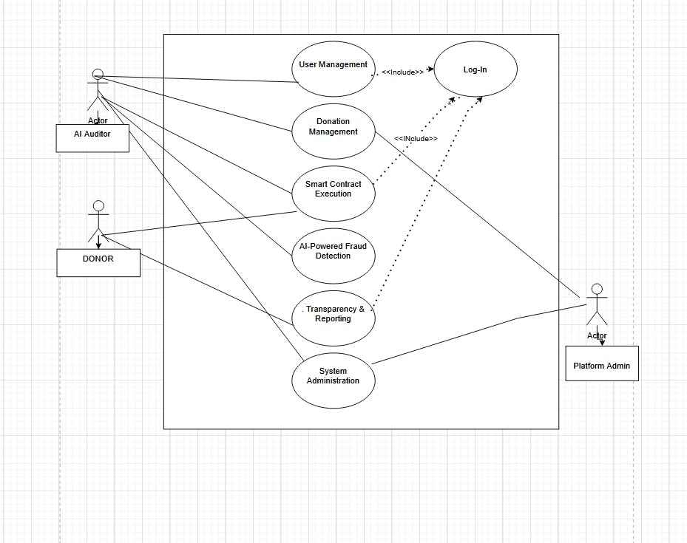

Class Diagram
